**CRITERIA M2**

**TASK 3**

**What does risk assessment mean?**

It is known as a method to identify the hazards that provide a negative impact of the ability of a workplace in order to do business. The risk assessments allow us to determine the risks in a business and provides methods to avoid these risks completely or atleast reduce the chances of risk. An RAF (Risk Assessment Framework) can be used in order to share the assessment data through which the company can identify the risks that can take place in their company’s infrastructure. Once the company uses RAF to find out these risks, they can work on effective solutions to these risks

**The importance of a Risk Assessment**

Risk assessment is crucial as it implies and important role in the health and safety of the industry’s management. The organization can use it for:

* Taking notes on the risks and hazards that the workers of the workplace are aware of.
* Paying attention to the health and safety concerns of the staff and to further promote a safer working environment and to allow the management to identify when and where such precautions should be taken
* Understanding which program of control to prioritize for a specific hazard
* To find out whether the current health safety precautions are sufficient or if any further improvement is required.

**Task 4b**

**What is meant by control measures?**

These are acts and procedures to ignore, mitigate or reduce the incidence of a danger that you have identified

Control measures to avoid accidents are:

1. Maintaining a clean workspace

In order to reduce the chances of risks taking place in a working environemtn it is very crucial to maintain a clean workspace because it plays a vital role in reducing the chance of an injury to anyone in the workplace. E.g. Tripping due to the wiring on the floor.

1. Stay updated on the maintenance of machinery in the workplace

It is necessary to maintain the machinery in a good and safe and working condition for workers who are entrusted to work daily in such sites by their managers. It can increase a great chance of risks or injuries to the worker if the supplied machinery is misfunctioning which can directly impact the efficiency of work as well

1. Provide a proper set of training to the workers in the workspace

Each and every employee should be given proper instructions and sufficient training in order to have a better idea of the tasks they are given. This way a worker can also have a proper understanding of the risks that might take place if certain precautions are not taken, and so the management can identify the risks and have better knowledge on how to manage with these risk factors.

1. Report the dangers and accidents

Workers are fully aware that a specific incident needs to be reported, and workers need to alert management to take immediate action. Accidents are warnings of unrecognized threats that may cause harm to the staff. Such risks must first be defined in order to eliminate such risks from the workplace. In order to investigate and locate and delete causes, it is important to have all injuries and accidents, including near misses reported.

1. Provide adequate symbols and signs

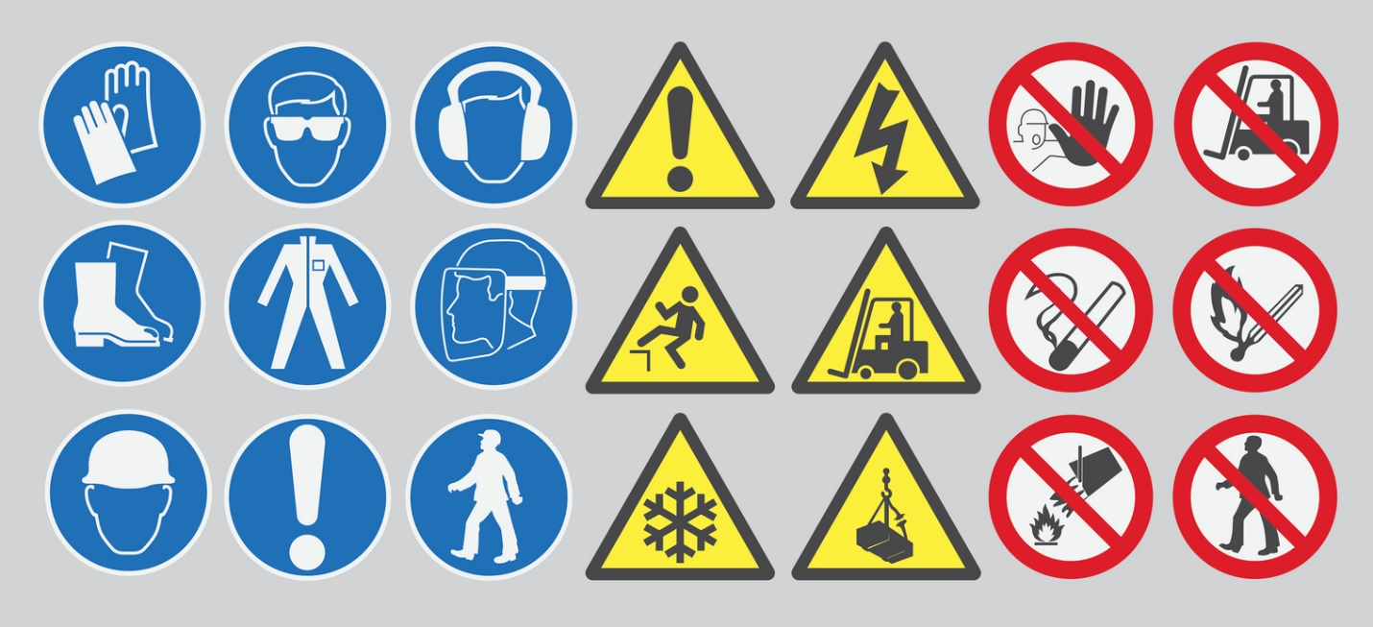

Figure 3: Health and safety hazard symbols

Workers should be provided with adequate symbols in each specific area of work in order to remind the employees to be aware of any safety precaution that should be taken prior to proceeding with their work.

**Task 5**

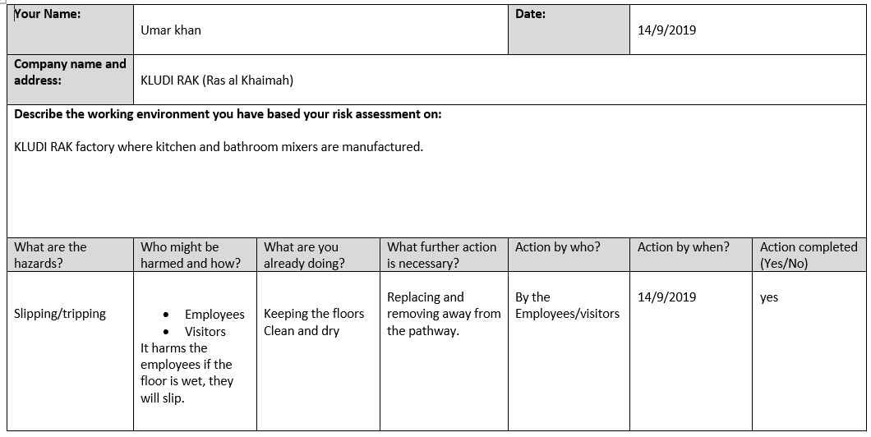

Abdulrehman razaq

If there is any wiring on the floor or perhaps the floor is wet, it can be a risk for the employees

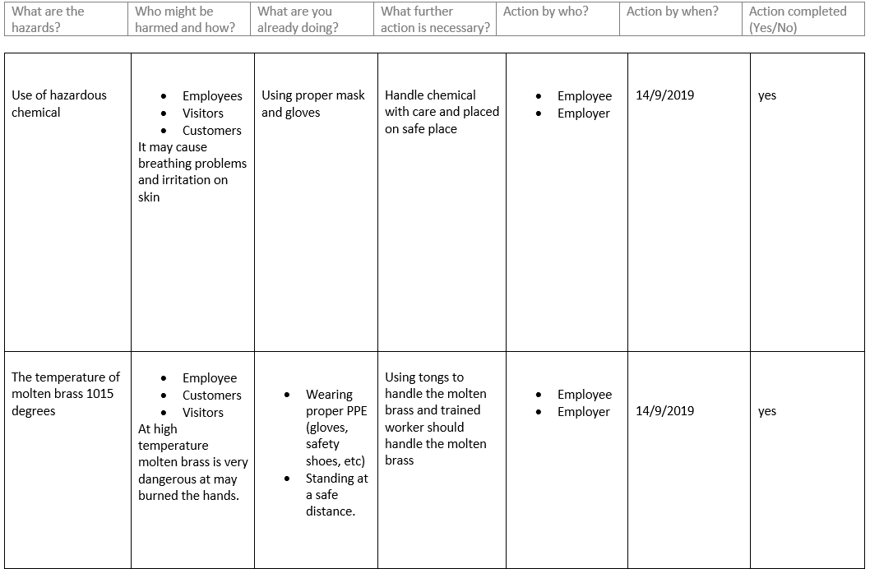

Wear safety gloves and use tongs while handling with molten brass to avoid burning of hands

At 1015 degrees molten brass can be very hot and could easily burn the hands

Place the chemical in a safe place to avoid risks and take safety precautions while handling it

Hazards such breathing problems or the irritation of skin may take place

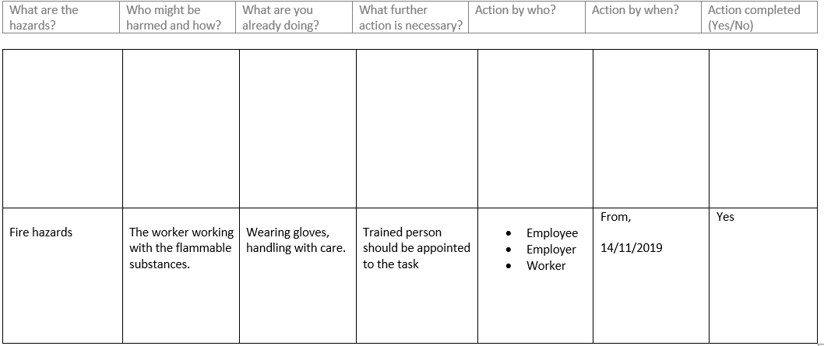

A trained personnel should be hired to deal with flammable substances and should take all kinds of safety precautions